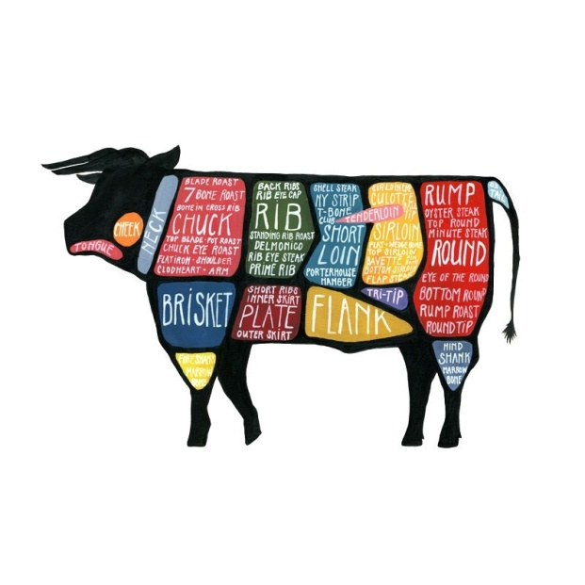
Felicity Farm

2023 Beef Order Form

Send to: Felicity Farm at 6984 Carmen Hill Rd, Vanderhoof BC, V0J 3A1
or e-mail to felicity@felicityfarm.ca Phone (250) 944-0275

GRASS-FINISHED BEEF

Felicity Farm cattle are raised in a low-stress environment on pasture their entire lives and are fed only fresh grass in the summertime and locally grown hay through the winter. They never receive any antibiotics or artificial growth hormones. Their diet contains all the vitamins, minerals and fresh water they need for a healthy and happy life.

Our beef is available in three quantity options: as a half (also known as a “side of beef”) or as a mixed quarter (that’s half of a half – and is an equal mix of cuts from the front and hind) or a 20 lb variety pack. Half and mixed quarter price is based on the hanging carcass weight (approximately 300-350 lbs for a half, and 150-175 lbs for a quarter). Prices include cutting, wrapping and freezing. Expect a yield of 60-70% retail cuts from the hanging carcass weight, depending on cutting instructions.

A 20 lb variety pack includes a mix of steaks, roast, hamburger, stew, etc.

Half: $6.50 / lb ______________________________

Mixed Quarter: $6.85 / lb _____________________

20 lb Variety Pack: $250 ______________________

20 lb Lean Hamburger: $160 ___________________

BEEF DEPOSIT: Per Half: - $100

Per Mixed Quarter: - $50

Per 20 lb Variety Pack: - $20

Per 20 lb Lean Hamburger: - $20

We take orders on a first-come-first-served basis. To reserve your order, we ask for a deposit. The deposit amount will be taken off the total price when you receive your order.

Total Beef Deposit: $ _____________________

Name_____________________________________________________

Total Deposit Enclosed $ _____________________ (Make cheque payable to Felicity Wilson)

(Or send an e-transfer to felicity@felicityfarm.ca – use “beef” as the secret password!)

Town_______________________

E-Mail___________________________________________ Phone_______________________

Thank-you for your order!

Privacy Statement - Information collected on this order form is used strictly for the purposes of filling your order and keeping in touch with you about your order. We do not share our customer information with other organizations.

